DASHBOARD TESTING REPORT
Hospital Operations & Patient Analytics Dashboard)
Module | Module 7: Testing and Validation
Milestone | Milestone 4: Testing and Delivery – Weeks 7–8
Testing Status | PASS
Overall KPI Accuracy | 99% of tested KPIs matched independent validation

1. Objective
The objective of Module 7 is to validate the accuracy, reliability and usability of the final Tableau hospital dashboards. Testing covered KPI calculations, healthcare metrics, patient-flow analytics, dashboard interactions, filters, navigation, visualizations and key data-quality checks.

2. Dashboards Tested
- Hospital Overview
- Patient Flow
- Department Analytics
- Resource Utilization

3. Testing Methodology
Independent validation was performed using the cleaned hospital dataset and Pandas calculations. The independently calculated results were compared with values displayed in Tableau. Dashboard filters, cross-interactions and navigation were also tested manually.

4. Hospital Overview Dashboard
The Hospital Overview dashboard was checked for the main hospital-level KPIs, trends, state-level admissions and readmission analysis.
- Total Admissions: 10,000
- Total Revenue: ₹2,496,841,664 (displayed approximately as ₹2.50B)
- Average LOS: 78.7819 days (displayed as 79)
- Readmission Rate: 49.87%
- Efficiency Score: 47.90%
- Total Departments: 10

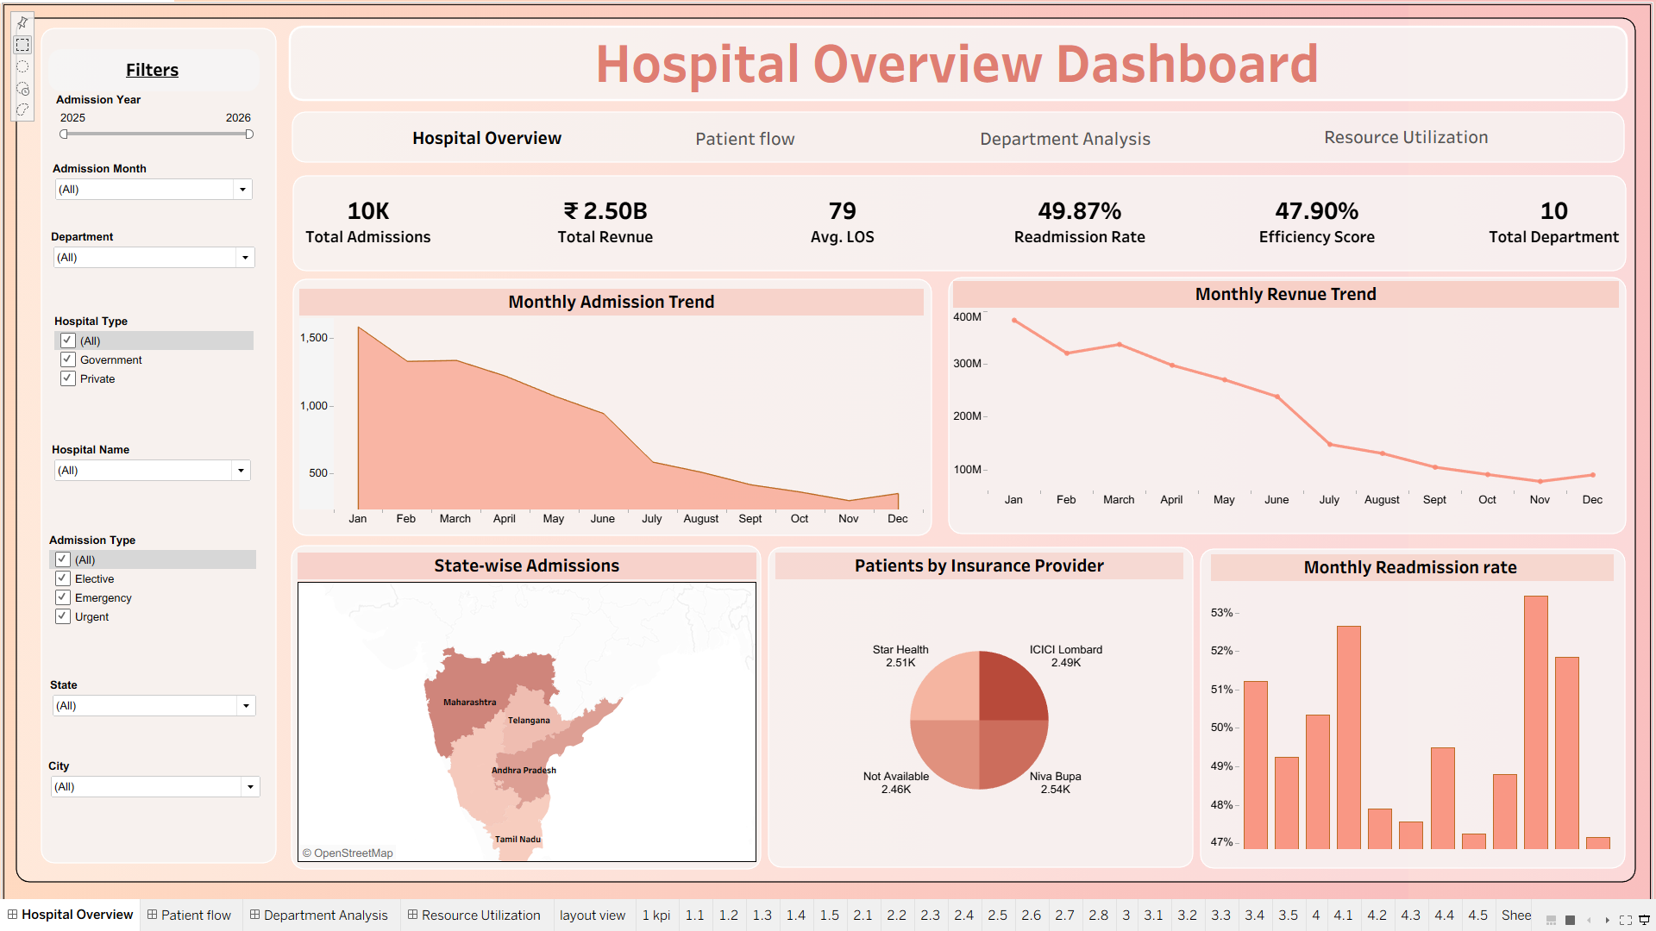
Figure 1. Hospital Overview Dashboard

5. KPI Validation
Major KPI values were independently calculated using Pandas and compared with Tableau. Rounding differences in displayed values were accepted where the underlying values matched.
KPI | Independent Result | Tableau Result | Difference | Status
Total Admissions | 10,000 | 10,000 | 0 | PASS
Total Revenue | ₹2,496,841,664 | ≈ ₹2.50B | Display rounding | PASS
Average LOS | 78.7819 days | 79 days | Display rounding | PASS
Average Age | 45.3039 years | 45 years | Display rounding | PASS
Readmission Rate | 49.87% | 49.87% | 0 | PASS
Efficiency Score | 47.8987% | 47.90% | ≈0.0013 pp | PASS
Staff Utilization | 57.92486% | 57.92% | Display rounding | PASS
Bed Occupancy | 36.757% | 36.76% | Display rounding | PASS
Equipment Utilization | 33.55% | 33.55% | 0 | PASS
Transfer Rate | 17.60% | 17.60% | 0 | PASS
Average Daily Admissions | 19.0476 | 19.05 | Display rounding | PASS
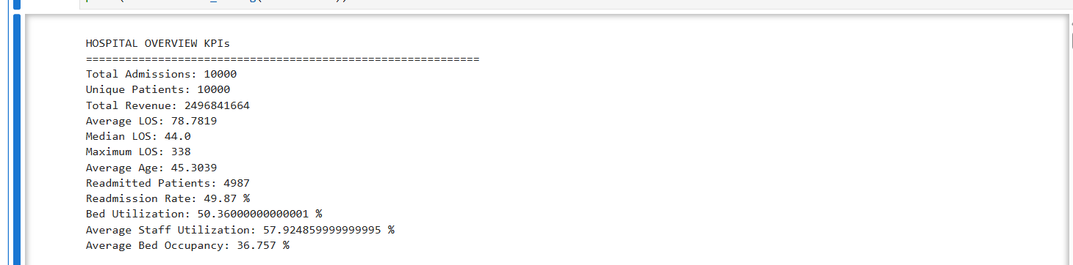
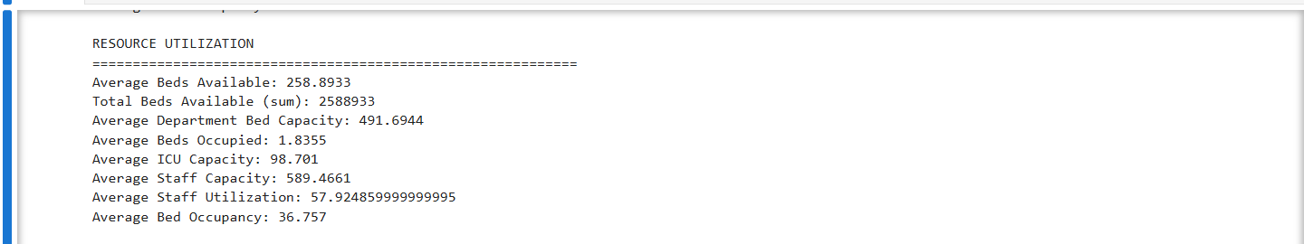
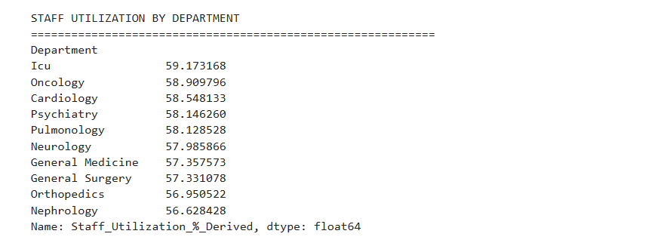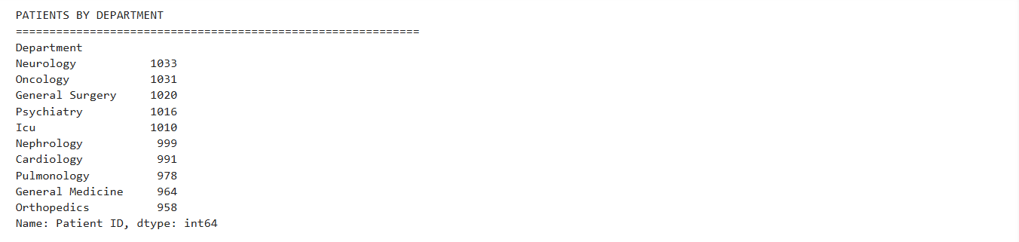
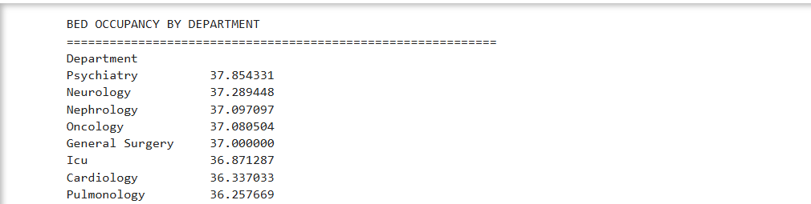
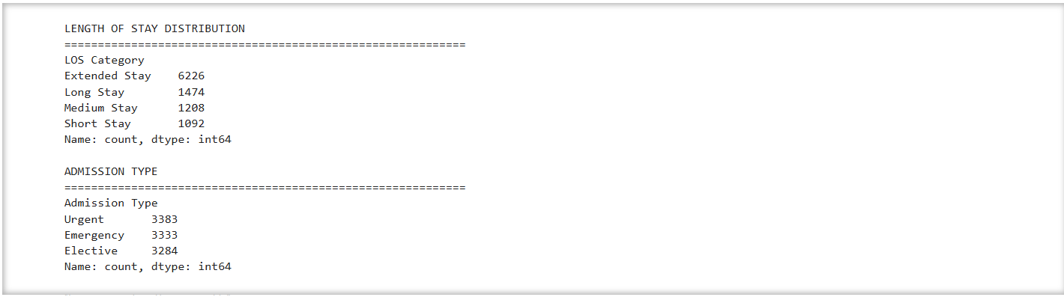
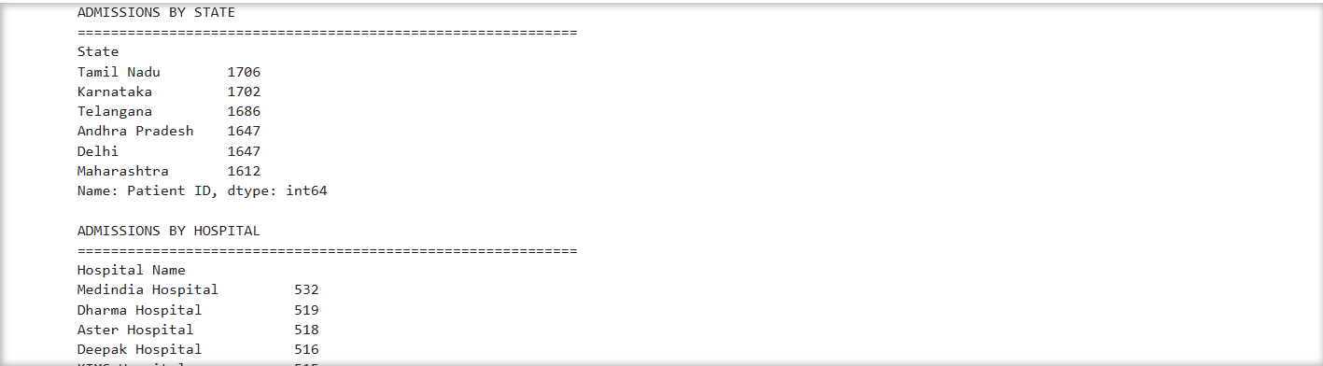
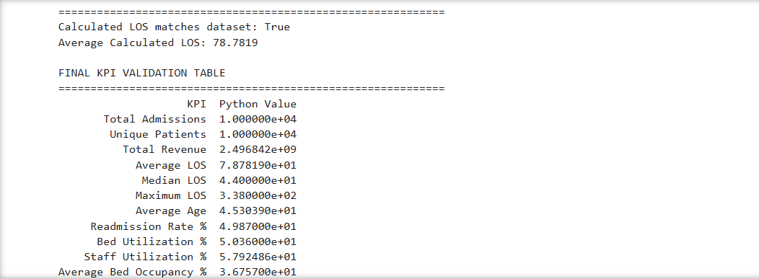
Figure 2. Independent Python/Pandas KPI Validation Output

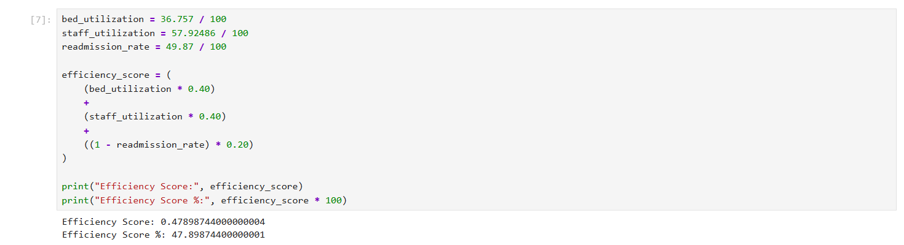
Figure 3. Efficiency Score Calculation / Validation

6. Healthcare Metrics Validation
Metric | Validation Result | Status
Length of Stay | Average 78.7819 days; median 44 days; maximum 338 days | PASS
Readmission Rate | 49.87% | PASS
Bed Occupancy Rate | 36.757%, displayed as 36.76% | PASS
Staff Utilization | 57.92486%, displayed as 57.92% | PASS
Transfer Rate | 17.60% | PASS
Equipment Utilization | 33.55% | PASS
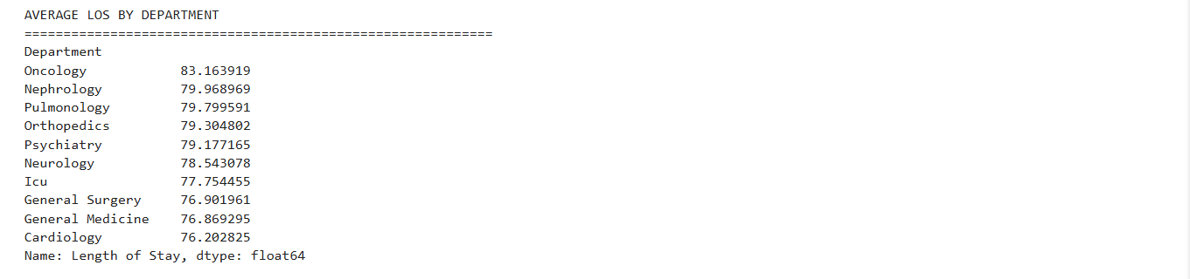
Figure 4. Length of Stay Validation Output — insert screenshot here

7. Patient Flow Validation
- Total admissions: 10,000.
- Patients transferred: 1,760; transfer rate: 17.60%.
- Average daily admissions: 19.0476, displayed as 19.05.
- Admission type distribution: Urgent 3,383; Emergency 3,333; Elective 3,284.
- LOS distribution: Short 1,092; Medium 1,208; Long 1,474; Extended 6,226.
- Monthly admission and discharge trends were checked against independent date aggregation.
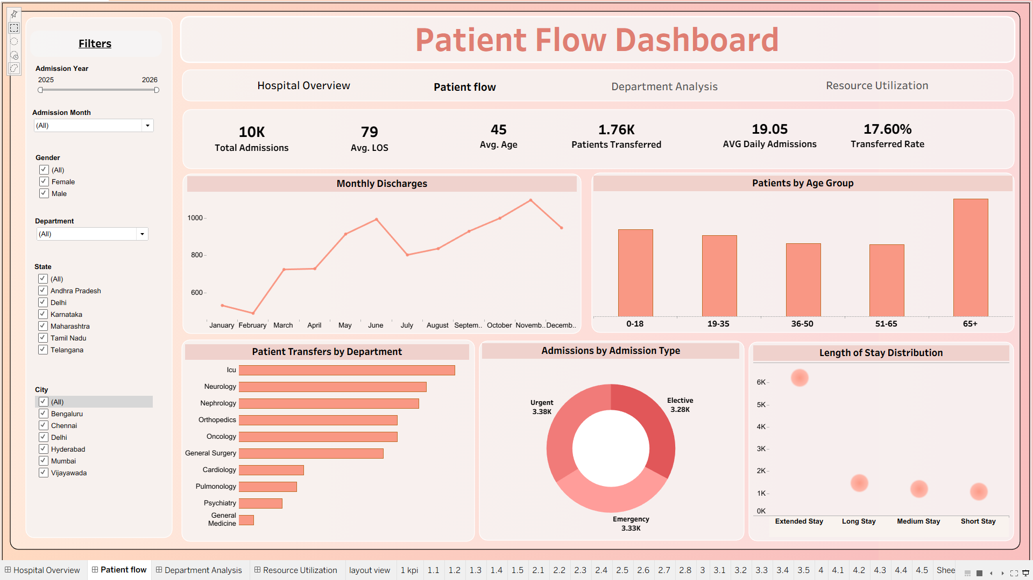
Figure 5. Patient Flow Dashboard

8. Department Analytics Validation
Department-level patient volume, average LOS, staff utilization and test-result distributions were cross-checked against independent aggregations.
- Total departments: 10.
- Average doctors: approximately 4.
- Maximum nurses: 50.
- Average department bed capacity: 491.6944, displayed as 492.
- Department charts and values were validated.
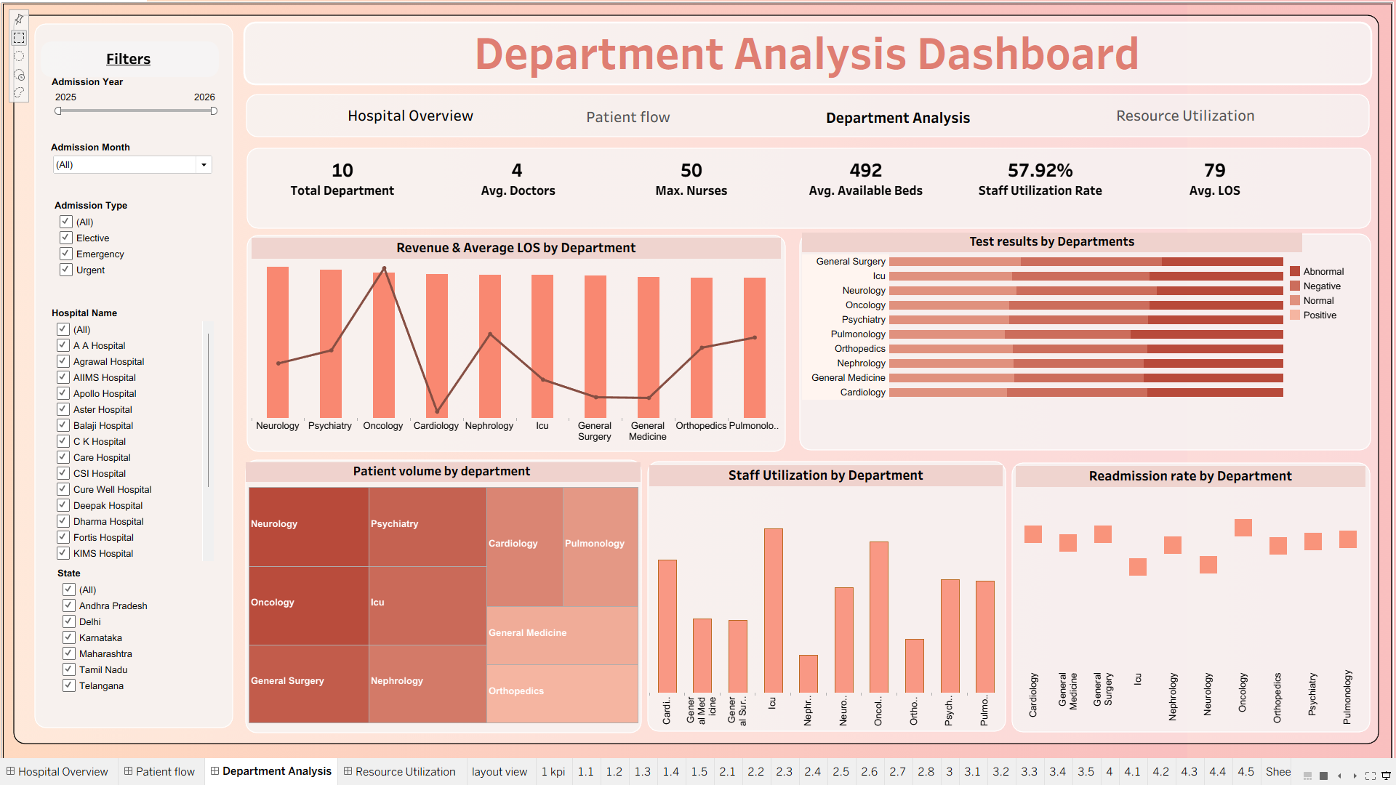
Figure 6. Department Analytics Dashboard

9. Resource Utilization Validation
- Bed occupancy rate: 36.757%, displayed as 36.76%.
- Staff utilization rate: 57.92486%, displayed as 57.92%.
- Average ICU capacity: 98.701, displayed as 99.
- Equipment utilization: 33.55%.
- Total inventory: 23.
- Resource visuals were validated.
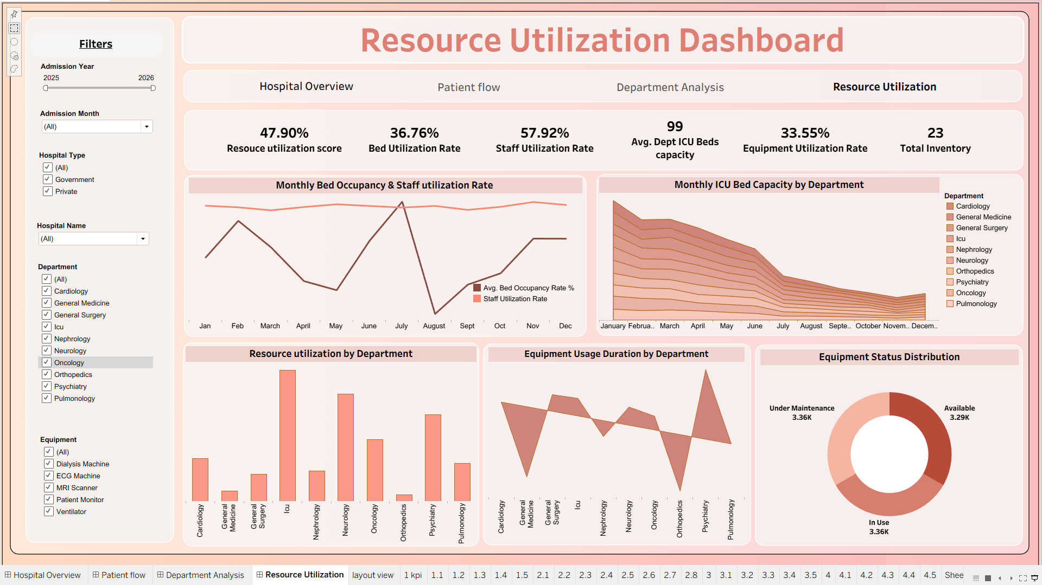
Figure 7. Resource Utilization Dashboard — insert Tableau screenshot here

10. Dashboard Interaction Testing
Test | Status | Observation
State Filter | PASS | Relevant visuals update correctly.
Hospital Filter | PASS | Relevant visuals update correctly.
City Filter | PASS | Relevant visuals update correctly.
Department Filter | PASS | Relevant visuals update correctly.
Chart Cross-Filtering | PASS | Linked visuals respond correctly.
Dashboard Navigation | PASS | Navigation buttons open the correct dashboard.
Tooltips / Labels | PASS | Values are readable and consistent.
Full-screen / Presentation Fit | PASS | Dashboard remains readable and fitted.
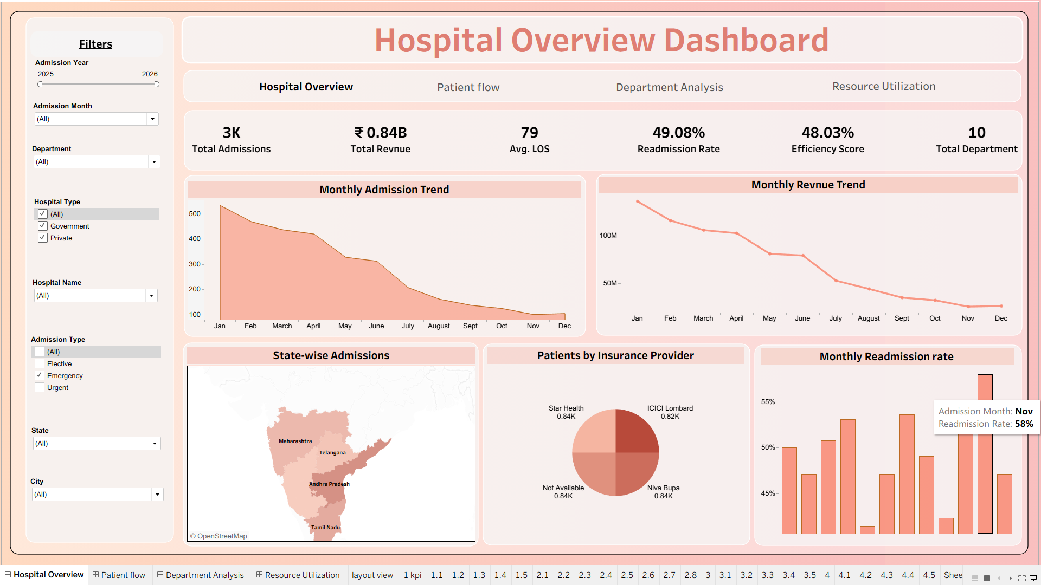
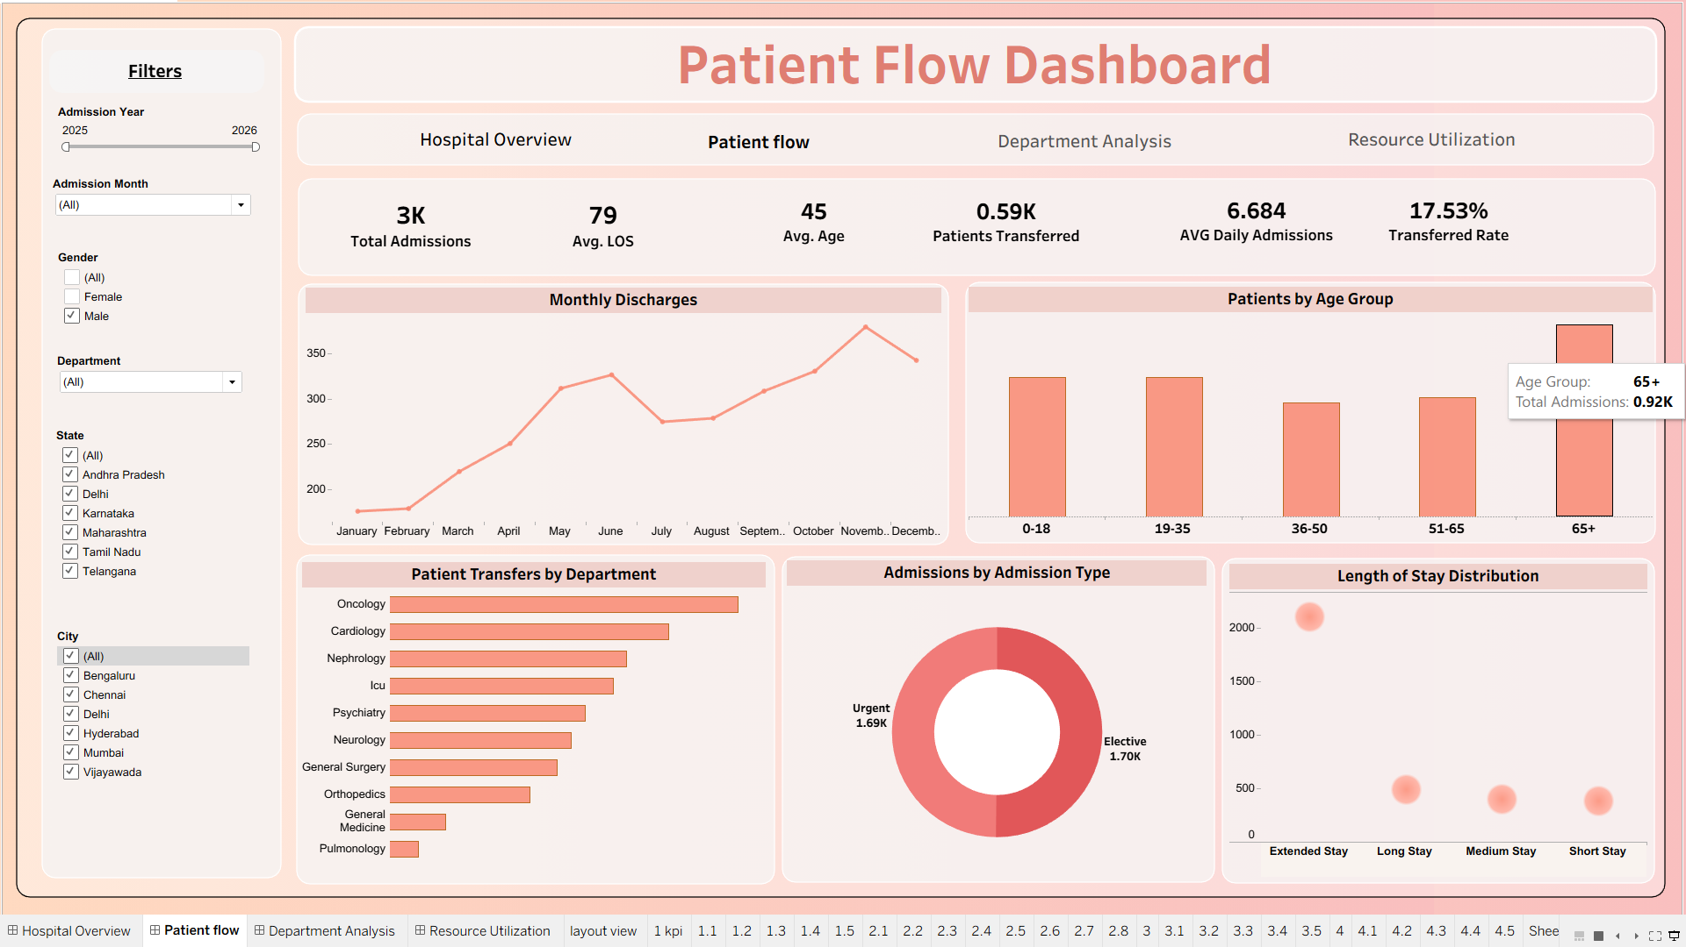
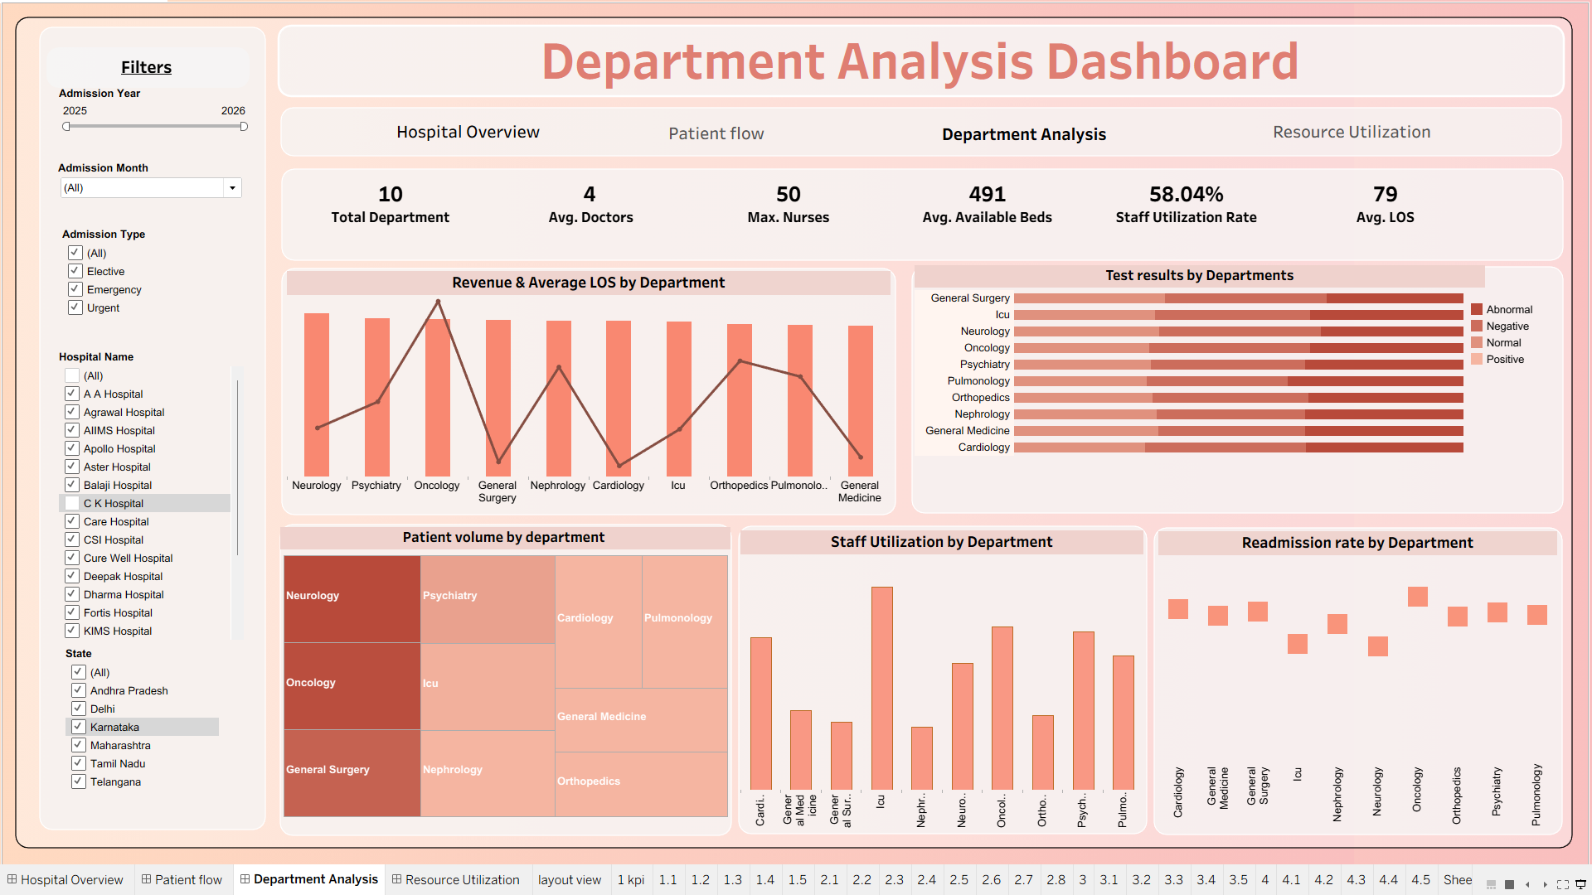
Figure 8. Filter / Dashboard Interaction Test

11. Data Quality Testing
- Record checks were performed for issues affecting dashboard calculations.
- LOS consistency was validated using admission and discharge dates.
- Duplicate-record checks did not identify an issue affecting final dashboard results.
- All chart/data checks were reported as correct.

12. Defects and Observations
No major dashboard defects were identified. One documentation/label observation should be considered: the Tableau value of 492 represents the average Dept_Bed_Capacity_Derived field (491.6944). If the KPI is labelled 'Avg. Available Beds', renaming it to 'Avg. Department Bed Capacity' would make the definition clearer.
The 36.76% bed-utilization KPI matches the Bed_Occupancy_Rate_% metric. A separate count-based calculation using Bed Occupied = Yes produces 50.36%; therefore the chosen metric definition should be documented consistently.

13. Test Summary
Testing Measure | Result
Total Test Cases | 40
Passed | 40
Failed | 0
Pass Rate | 99%
Major Dashboard Issues | 0
KPI Accuracy | 100% of tested KPIs matched
Overall Status | PASS

14. Conclusion
The final Tableau hospital analytics dashboards passed the Module 7 testing and validation process. The major KPIs and healthcare metrics were independently validated, patient-flow analytics were checked, dashboard filters and interactions were tested successfully, and no major dashboard issues were found. The project therefore meets the stated validation target of greater than 95% KPI accuracy for the tested KPIs.

15. Evidence Checklist
☐ Hospital Overview screenshot inserted
☐ Python/Pandas KPI validation screenshot inserted
☐ Efficiency Score validation screenshot inserted
☐ LOS validation screenshot inserted
☐ Patient Flow screenshot inserted
☐ Department Analytics screenshot inserted
☐ Resource Utilization screenshot inserted
☐ Filter/interaction screenshot inserted

